***Facebook Messenger Analysis***

Facebook Messenger is an American messaging app and performs developed by Facebook, Inc.

There are steps to take messenger analysis as follows:

Step 1: First download messenger from history of facebook messenger.

Step 2: Unzip your data into the directory of your choice.

Step 3: Identify a person whose chat history you want to analyze.

Step 4: Find your file (.json format only) listing all of their messages with you (named after their username).

We will refer to this file's path as **${FILE}**.

Step 5: Clone this repository and change directory into it.

git clone https://github.com/dmhacker/facebook-message-analysis && cd facebook-message-analysis

Step 6: Install any dependencies.

pip install -r requirements.txt

Step 7: If you get an NTLK download error, use this command to resolve the issue. It will tell NTLK to download the appropriate stopwords file.

python

>>> import nltk

>>> nltk.download('stopwords')

>>> quit()

Step 8: Run the analyzer.

python fbmessages ${FILE}

In a few seconds, you should get some nice visualization.

Example:

**Private messages**

private_message_analysis.py analyzes one to one messages. All methods are in the main method and commented out by default. Generally, four statistics are supported:

* Characters: total characters
* Messages: total times enter is pressed
* Clusters: all messages sent before being interrupted by other participant
* Words: count of elements split by spaces

The supported time periods are Year, Month, Day

All friends were initialized in friends.py. To access a friend in private_message_analysis.py, use the variable friends.ABE_DEG

I used a name hash in the following example outputs so they don't use friends' real names

graph_stat will create a bar graph of a given stat over a period. Default graphs Messages per Year between you and your friend (most messaged friend).

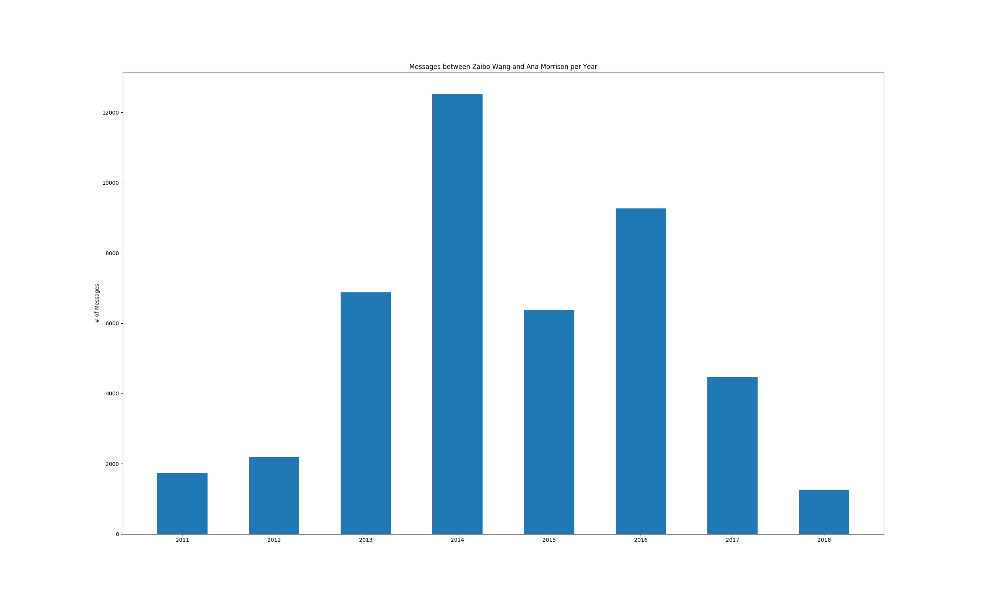

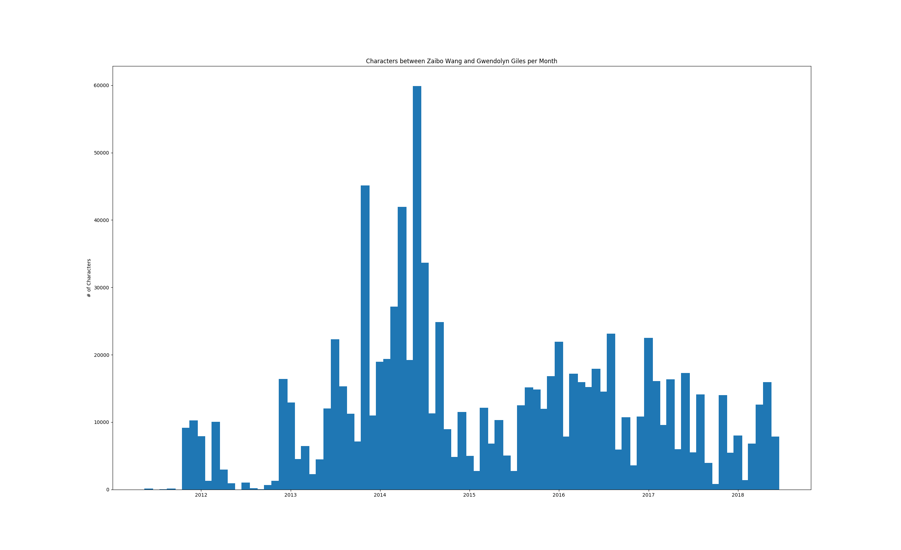

count_link gives below absolute count and ratio link by a person. Here I put a default, it only top 20 messages friends.

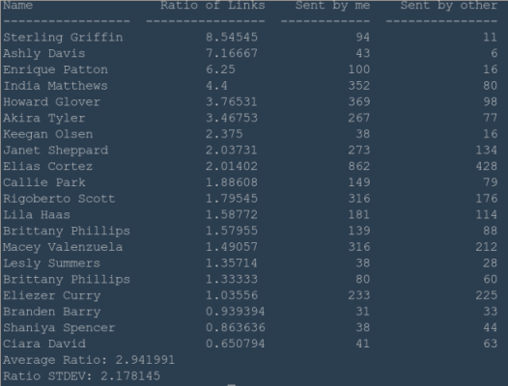

**Group Messages:**

group_message_analysis.py  these code to analyze group messages.  It is easiest way to pass group messages.json. The main method is group_message_analysis.py.

Their to find some difficulty to send my messages then find_groupchat() in setup.py.  Let me specify the condition the group messages have more than 15 participants. I added them in GROUPCHAT variable. i.e. setup.py which generate the groupchats in friends.py . These process can be passed to main method friends.${chat_name}

Result:

